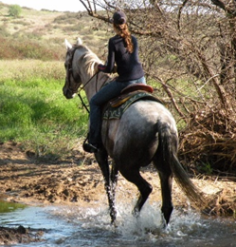
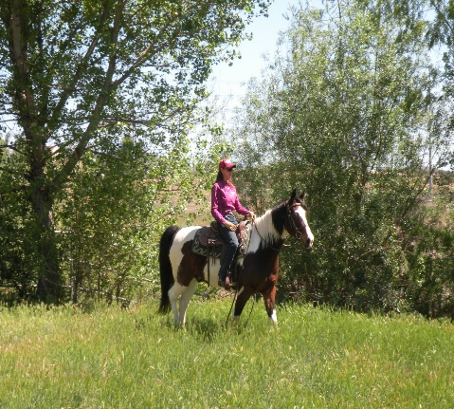
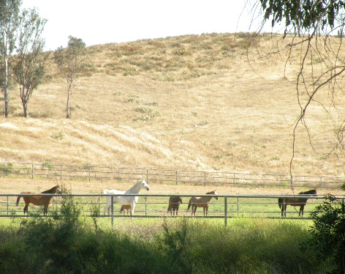
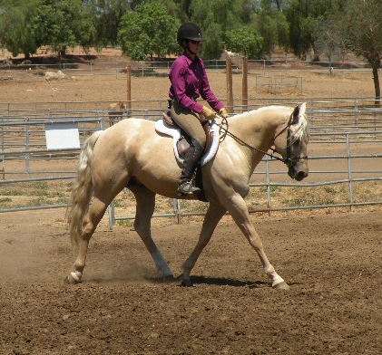
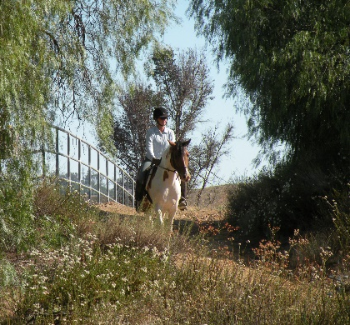
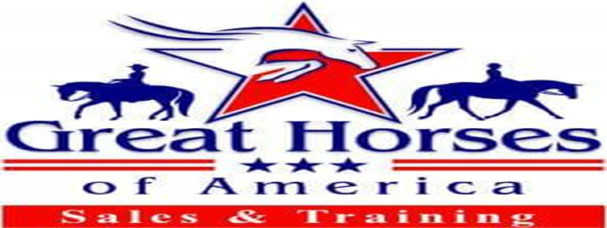
Boarding Rates 2023
Community Living Paddock $350
24 x 24 Corral $500
Includes Turn-Out 3x/week
24 x 48 Corral $400
48 x 48 Corral $450
60 x 80 Corral $500
30 x 100 Corral $550

Amenities
900+ Acres of Private Trails
120 x 140 Arena
60 x 80 Arena
95 ft. Large Round Pen
60 ft. Round Pen
Private Gated Facility
Professional Staff
Certified Riding Instructor and Horse Trainer on Site
Ability to Custom Tailor to Accommodate You and Your Horse’s Unique Needs
Great Horses of America
Call: 619-572-3087
Email: tekackert@gmail.com
Visit: www.greathorses.org
34221 Briggs Rd. Menifee, CA 92584
